Measuring the Impacts of COVID-19 Pandemic on Public Transit Demand in US

Luyu Liu1, 2, *, Harvey J. Miller1, 2, Jonathan Scheff3

1 Department of Geography, The Ohio State University, Columbus, Ohio, USA

2 Center for Urban and Regional Analysis, The Ohio State University, Columbus, Ohio, USA

3 Transit App Inc., Montreal, Quebec, Canada.

* Corresponding author

E-mail: liu.6544@osu.edu

**Abstract:** The COVID-19 pandemic and related restrictions led to major transit demand decline for many public transit systems in the United States. This paper is a systematic analysis of the dynamics and dimensions of this unprecedented decline. Using transit demand data derived from a widely used transit navigation app, we fit logistic functions to model the decline in daily demand and derive key parameters: *floor value*, the apparent minimal level of demand and *cliff* and *floor points*, representing the initial date when transit demand decline began and the final date when the decline decreased. Regression analyses reveal that communities with more essential workers, a more vulnerable population (African American, Hispanic, female, and people over 45 years old), and more Coronavirus Google searches tend to maintain higher levels of minimal demand during COVID-19. Additionally, approximately half of the agencies experienced their decline before the local spread of COVID-19 likely began and most of them are concentrated in Midwest; however, almost no transit systems finished the decline process before the local community spread. We also compare hourly demand profiles for each system before and during COVID-19 using ordinary Procrustes distance analysis. The results show substantial departures from typical weekday hourly demand profiles. We also find that COVID-19 shifted morning rush hours differently for various cities, but shifted afternoon rush hours generally earlier. Our results provide insights into public transit as an essential service during a pandemic.

Keywords: COVID-19, public transit, transit dependence, essential jobs.

1. **Introduction**

COVID-19, a novel coronavirus disease, emerged in December 2019 to become a global health crisis due to its high contagiousness, fatality rate, and lack of known vaccines or treatments. To deal with the pandemic, from early February 2020 the U.S. Centers for Disease Control and Prevention (CDC) recommended social distancing, self-quarantine, and working from home to stop the spread of the virus; states and cities followed these and similar guidelines, closing schools and businesses, and issuing calls to stay at home. These sudden and unprecedented shutdowns led to declines in travel demand at all geographic scales and all modes [1,2].

Public transit systems in the US experienced dramatic drops in demand and ridership due to COVID-19. In Washington DC, Metrorail ridership declined by 90% and bus ridership declined by 75% by the end of March 2020 [3]. Smaller transit system also experienced major declines; for example, El Dorado Transit (California) experienced a ridership decline of 75% [4]. The consequent drop in fare box revenue may lead to subsequent cuts in services, particularly since cash-strapped local governments may not have the ability to increase their support. The decline in ridership is unequal across social dimensions since many information, managerial, tech, and knowledge workers can telecommute while people with jobs that demand physical presence still need to travel to work [5]. The remaining public transit users during a pandemic such as COVID-19 are likely "captive" riders who depend on public transit for mobility and accessibility to jobs, health care, and services [6]. Since only essential businesses and services were open during this period, these captive riders were also likely performing necessary activities for themselves or society, highlighting the nature of public transit as a critical infrastructure [7].

In addition to the closing of businesses, and substitution of telework for onsite work, another factor affecting the decline of public transit demand during a pandemic is fear. According to an online survey, about 48% of Americans and 40% of Canadians feel that using transit poses a high health risk due to the coronavirus [8]. In an analysis of public transit ridership in Taipei during the 2003 SARS pandemic, Taipei underground lost almost 50% of daily ridership during the peak of the SARS pandemic [9]. An analysis of Seoul transit system smart card transaction data during the 2015 MERS outbreak shows variations in the decline in trip frequencies across different public transit modes, different populations, and neighborhoods. The study finds that fear of the pandemic significantly influenced travel behavior. The ability for people to change their daily routine measured by land value and regional characteristics are the two primary determinants of shifted travel behavior [10].

COVID-19 provides an unfortunate but imperative juncture to understand the differential impacts of a major shock such as a pandemic on public transit.. In this study, we use the data from the Transit app, a widely used mobile phone-based transit planning app, to conduct a comprehensive analyses of the impacts of COVID-19 on US public transit systems. We fit logistic curves to describe the decline in daily transit demand across public transit systems, extracting key parameters: i) *floor value*, the apparent minimal level of demand; ii) *cliff and floor point*, representing the initial date when transit demand began and the final date when decline decreased; and iii) *decay rate*, representing the speed of the demand decline. We conduct regression and correlation analyses relating the floor values and decay rates to socioeconomic and demographic factors in each community. We also compare the distance between the cliff/floor points and the first date of local community spread to measure whether public transit users in different metro areas reacted at different speeds to the unfolding pandemic. Finally, we use hourly transit demand data to capture COVID-19’s impact on daily patterns of transit demand; we measure the similarity of hourly demand profiles during the COVID-19 pandemic compared to the adjusted normal demand profiles. We conclude that COVID-19 had major impacts on transit systems in different dimensions and demonstrate the social equity issue of transit usage during the pandemic; we propose some future directions for transit studies in the context of pandemics.

1. **Data and methods**

In this section, we describe the primary data sources in our study, namely, Transit app demand data and COVID-19 case numbers. We also describe our model of daily transit demand decline, the logistic curve. From these fitted curves, we derive several parameters describing the declines in daily transit demands: i) *floor values* measuring the base levels of transit demand; ii) *cliff and floor points* indicating when demand decline started and stopped; iii) the *decay rate* measuring the speed of transit demand decline, and; iv) *response intervals* capturing the time lags between the first reported case in a community with respect to when decline started and stopped. Moreover, we describe *ordinary Procrustes analysis* for measuring differences in hourly travel demand during and before the COVID-19 pandemic, and weekday versus weekend demand during the pandemic. Finally, we investigate the morning and afternoon rush hour’s shift due to COVID-19.

* 1. **Data sources**
     1. Transit demand

Since it is difficult to obtain comprehensive public transit ridership data at a national-scale, we use data from the Transit mobile phone app (transitapp.com) as an indicator of changes in daily and hourly transit demand. Transit is a popular mobile phone app providing real-time public transit data and trip planning. The app covers over 200 cities around the world with more than five million download on Android platform [11] and 73.5 thousand ratings on Apple App store [12]. We treat app usage as an indicator of real-time demand and an approximation of general public transit demand [13]; we also examine this empirically (below). The data provided by Transit via their daily updated webpage are change values expressed as a set of percentage of app usage relative to the same date last year, adjusted for annual growth [13].

To assess the authenticity of the Transit app usage data as a measure of transit demand, we compare ridership decrease reports derived from individual transit systems' websites and local news outlets. Most transit systems do not release estimates for every date; instead, many report single estimates for a given date. We compare these ridership decrease reports with the corresponding estimates from the Transit app data on the same date for 40 transit systems that we could trace the actual ridership decrease value. The average difference between the Transit app estimate and agency reported value is 3.7%; a paired T-test indicates that we cannot reject the null hypothesis that the mean difference is zero (p = 0.14 > 0.05). However, the standard deviation of the differences is 15.96%; this may be due to the varying definitions of normal ridership level among agencies. Although the test suggests the Transit app data are a good overall approximation of public transit demand, it is important to note that the Transit app decline values as well as the agency values are both inferential estimates. Ridership counts from agencies, especially daily ridership counts (as opposed to monthly) vary greatly in methodology, and agency counts during COVID-19 are particularly prone to error when back-door boarding, fare-free service, and other changes affect the accuracy and precision of ridership estimates. Regarding Transit, its estimates are based on app activity as a proxy for ridership, and its sampling frame will not include individuals who cannot afford a smart phone and data plan, cannot use the app due to different abilities, or choose not to use it. However, these disadvantages are compensated by the large Transit app user base that allows comparison across transit systems.

The daily Transit data include demand decrease estimates for 182 public transit systems across the United States, Canada, Australia, New Zealand, and France. We select 113 county-level transit systems in 63 metro areas, 52 counties, and 28 states across the United States. We exclude 7 state-level or cross-county systems if their ridership could draw from large and geographically diverse areas, such as Pacific Surfliner, which extends to the whole South California coast and Metro-North Railroad, which crosses multiple counties and states in the Northeast United States. The time period of daily data is from February 15th to May 17th. We also use hourly demand decrease for 93 public transit systems across the United States. Hourly data’s time period is from March 16th to May 10th.

* + 1. COVID-19 case numbers

We use the daily case numbers for each county from the COVID-19 Surveillance Dashboard produced by University of Virginia [14], the COVID-19 Dashboard produced by John Hopkins University [15], and COVID-19 maps and county-level dataset produced by USAFacts [16]. The data include all county-equivalents’ confirmed cases in the US for every day. To find the linkage between the case numbers and the demand decrease, we geocoded each transit system to its corresponding county-equivalent.

* 1. **Logistic model for daily transit demand change**

Based on a visual examination of the data, we note a pattern of stable demand before the COVID-19 crisis, a period of decline, followed by re-stabilization at a lower demand level. This is a pattern described well as a logistic (anti-) growth process, expressed using a logistic or sigmoid function:

|  |  |  |
| --- | --- | --- |
|  |  | (1) |

where *B* is the minimum value for the decline, *b* is the pre-COVID baseline value, *k* is the decline rate; *t* is time (day) and *t0* is the time when the function reaches the midpoint. We fit each transit system’s demand data using logistic model individually and calculate key parameters that describe the process for each transit system.

* + 1. Floor value

The parameter *B* represents how far the curve decreases from the normal level as demand re-stabilizes at a lower level; we call this the *floor value.* This represents the ratio of public transit users in the system that still would not or cannot stop needing it regardless of the pandemic. This demand level is not necessarily a persistent state: demand may destabilize and grow again due to external factors, such as re-opening of businesses or stay-at-home fatigue. The floor value represents the base level of demand from the initial shock to the system.

We examine relationships between the estimated floor values and socioeconomic factors using linear regression analysis. The county-level socioeconomic data are from the latest American Community Survey (ACS) 5-year estimate table (2014 - 2018). We derive several socio-economic indicators. First is the *ratio of population with non-physical occupations*. Similar to *life fixity* [10], this measures the population’s degree of freedom to change the routine of their daily life: it represents how many people can work from home thus avoid regular transit commuting to reduce contagion risk. If a community has higher ratio of non-physical jobs, more workers may work from home, meaning that transit demand will decrease more. We use the occupations statistics for employed civilian population 16 years and over from the ACS data. The table contains the number of employed population in different industries. According to the statistics released by US Bureau of Labor Statistics, Information, Financial activities, and professional and business service have the highest percent who can work from home [5,17]. Among these occupation categories in the ACS table, we assign “management, business, and financial operations occupations”, “professional and related occupations”, and “office and administrative support occupations” as the occupations with which people can work from home remotely.

*Income* is a socioeconomic factor that relates to job composition. Also, transit users tend to skew toward lower incomes in the United States. We use the median income data from ACS.

A third set of indicators is the *ratios of minority and female population*, including African American and Hispanic populations. Many studies have demonstrated the disadvantaged status of African American, female, and Hispanic populations in mobility and job accessibility across different metro areas in the United States [18–20]. Therefore, we investigate the relationship between floor value and each vulnerable group’s ratio. We derive the sex, race, and Hispanic population data from the ACS data.

A fourth socioeconomic indicator is community *age structure*. Older individuals are more at risk of hospitalization and death from COVID-19 [21]. We use 45 years as a threshold to identify high-risk populations. We measure the ratio of people with age over 45 from the ACS 5-year estimates (2014 - 2018) data.

Moreover, we use measures of *awareness*. If local residents are aware and concerned about COVID-19, the floor value may be lower because more people will try to avoid public transit trips. To test this, we use the Google search trend index to represent the awareness of the local people [22–24]. We collected the average Google search trend data for different designated market area that each transit system locates in for 90 days from January 18th to April 17th 2020 [25], the latter being the latest day we witnessed any system experiencing further significant decline. We select “Coronavirus” over “COVID19” as the search keyword for its popularity among the public [26].

Finally, *transit dependency* is also a potential factor affecting the transit system's floor value. If an area has more people depending on transit, the usage rate of transit during the pandemic is supposedly higher. We derive the ratio of people who transit to work and the percentage of house units with no vehicle access from ACS data to infer transit dependency.

To supplement the analysis, we also refer to the user survey results conducted by Transit app about the demography of the passengers during the pandemic. The survey was conducted in early April, 2020 across the United States (n = 15000) and Canada (n = 10000) via the Transit app interface. The survey investigated the age, race (including Spanish speakers), gender, trip purpose, occupation composition of the passengers who stick to transit systems during the pandemic [13,27,28].

* + 1. Cliff/floor points and decay rate

The *cliff point*  and *floor point*  are time points when demand decline started and when it re-stabilized. We calculate these from the logistic curve using confidence interval theory rather than the observed data to provide more stable estimates. We derive these measures by first constructing the probability density function of the normalized logistic function F(x):

|  |  |  |
| --- | --- | --- |
|  |  | (2) |
|  |  | (3) |
|  |  | (4) |

where *P* is the probability density function of the normalized logistic function; to normalize the logistic function, we subtract the normal value *b* and divide the result by *B* to construct the *P* function so that . α is the confidence threshold. From equations (2), (3), and (4), we can see that ; α = 0.05 ensures that 95% of the decline falls between the cliff and floor points . From the formula, we give the direct definition of cliff and floor point:

|  |  |  |
| --- | --- | --- |
|  |  | (5) |
|  |  | (6) |

The cliff point is the first daywhen the demand curve began to diverge from normal—i.e., when transit users start to avoid the transit. The floor point is the day when decline slows and transit demand has re-stabilized. Naturally, we can expect the cliff point to be impacted by the policy of local government. We therefore collect the date when each state declared the state of emergency due to COVID-19 and conduct correlation analysis between the emergency date and the cliff point.

Parameter *k* represents the rate of transit demand decline; we therefore define it as *decay rate*. It indicates the speed of response from users who have the ability to stay at home or not use public transit. We also conduct the correlation analysis between decay rate and cliff/floor point.

* + 1. Response intervals with incubation lags

*Response intervals* compare the time of community spread with the initiation (cliff point) and conclusion (floor point) of transit demand decline in each system. This measures the responsiveness of transit demand to the pandemic. Although declines in transit demand are not welcome from a revenue perspective, lower demand means fewer people potentially exposed on transit; it also means the remaining dependent riders are less exposed and can practice social distancing more easily. Ideally, a transit system initiates and finishes its demand decline before there is community spread.

Meanwhile, the date of first reported community spread is not necessarily the first date of actual spread due to the incubation period for the disease. The median of incubation period is five days and can be as long as 14 days [29]; the virus can also spread asymptomatically [30–32]. Additionally, the availability of testing kits and response times from local authorities can lead to an underestimation of total cases [33,34]. Since the incubation period and case load accuracy both vary, we introduce *incubation lag* as a parameter into response intervals relative to the cliff and floor points:

|  |  |  |
| --- | --- | --- |
|  |  | (7) |
|  |  | (8) |

where is the date of first confirmed case in the county of the transit system; *l* is the incubation lag; and are the cliff and floor point; and rc and rf are the response intervals. A positive response interval means that the transit users responded earlier than the epidemic spread; the larger the value is, the earlier the transit users responded relative to the onset of the spread of the virus. The cliff response interval indicates transit users’ awareness while the floor version indicates the response time (a negative floor response interval that is large in magnitude, for example, indicates that public transit reached its minimum level long after the first confirmed case in the county).

* 1. **Change in daily transit demand dynamics**

The analyses based on the average daily transit demand shows the coarse-grained temporal variation among different transit systems. Transit demand dynamics within each day can also change during a pandemic. For example, Fig 1 below shows changes in transit demand by hour before (blue) and during COVID (orange) for the New York City subway. The higher and peaky curve is a typical US daily travel demand pattern, with morning and afternoon peak demand periods corresponding to commuting to and from work (for the “standard”, nine-to-five work day), respectively. In contrast, the COVID demand curve indicates not only lower demand, but less pronounced peak demand periods.

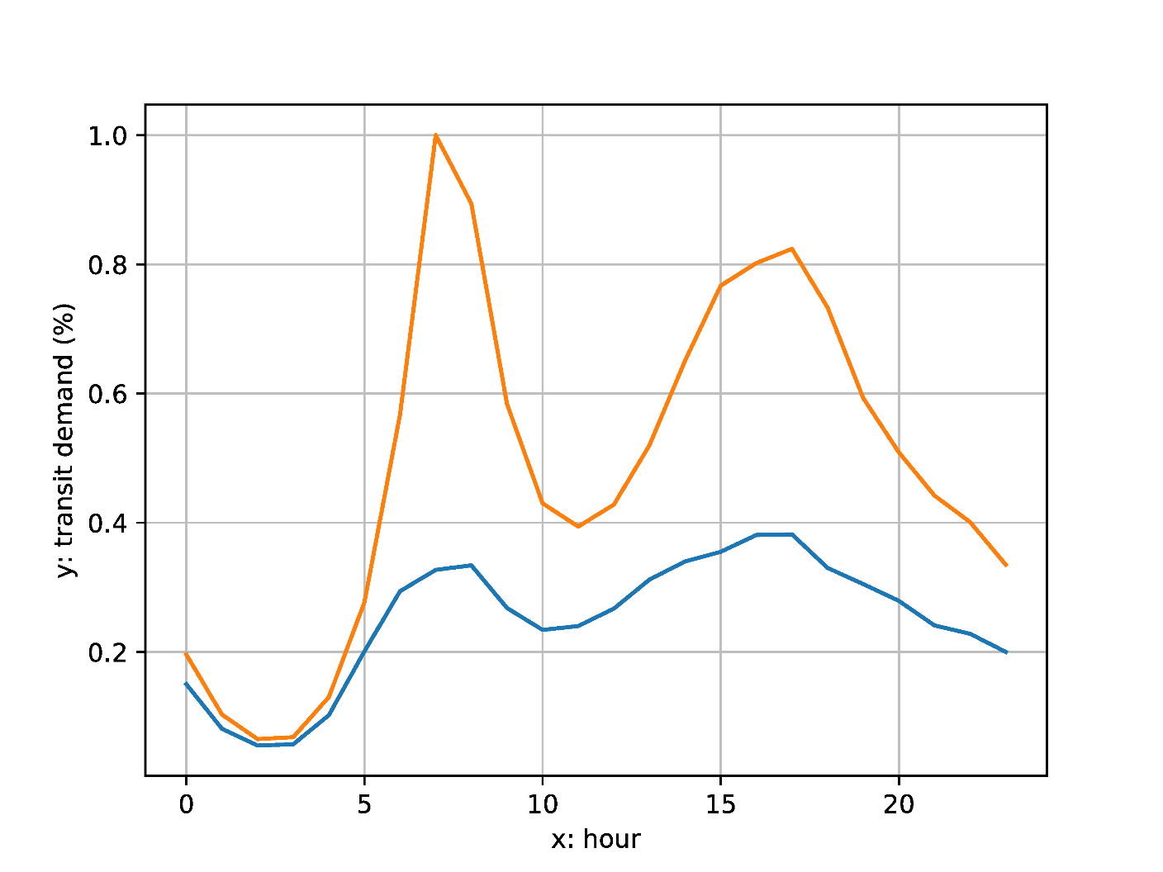

Fig 1. MTA New York City Subway hourly transit demand curves (blue: typical curve; orange: COVID curve)

We utilize the shape analysis technique of *ordinary Procrustes analysis* to measure differences between hourly travel demand during and before the COVID pandemic, and weekday versus weekend demand during the pandemic. This involves measuring the transformations required to superimposing the two curves. In traditional Procrustes analysis for arbitrary shapes, these transformations are panning, scaling, and rotating [35]. In the case of one-dimensional curves, only scaling is appropriate. We use a stretch factor *p* as a multiplier to fit two curves so that their Procrustes distance is minimized:

|  |  |  |
| --- | --- | --- |
|  | Minimize: | (9) |

Where *S(p)* is the Procrustes distance between the two curves, *p* is the stretch factor, *h* is the number of data points in the dataset, *f(t)* and *g(t)* are the two curves’ value at time *t*. The solution to this optimization problem is:

|  |  |  |
| --- | --- | --- |
|  |  | (10) |

The optimal Procrustes distance *S(p*)* is a measure of the difference in the shapes of the curves: a larger Procrustes distance means bigger differences in the shape of analysis between the two curves.

We measure the Procrustes distances between the normal hourly demand curve and COVID curve for each day between March 16th to May 10th and calculate the average. We also calculate the average Procrustes distance between Wednesdays’ (representing a typical weekday) and Sundays’ (representing a typical weekend) demand profiles in each week. Under normal travel demand patterns in the US, weekday and weekend hourly demand profiles are different, with no typical twin demand peaks on weekend days. We wish to see if weekday and weekend public transit demand profiles have converged during COVID.

1. **Results**
   1. **Floor values**

The average floor value of 113 transit systems is -72.66% (standard deviation = 11.58%) and maps floor values for the US public transit systems in our study. We express these values as negative differences from previous demand levels: larger negative numbers are lower floors. We can see clear geographic differences: cities in the Deep South and Midwest have higher floor values (i.e., negative but smaller in magnitude—less decline in public transit). Meanwhile, high tech cities such as the San Francisco Bay area and university cities such as Ithaca, Ann Arbor, and Madison generally have a very low floor value.

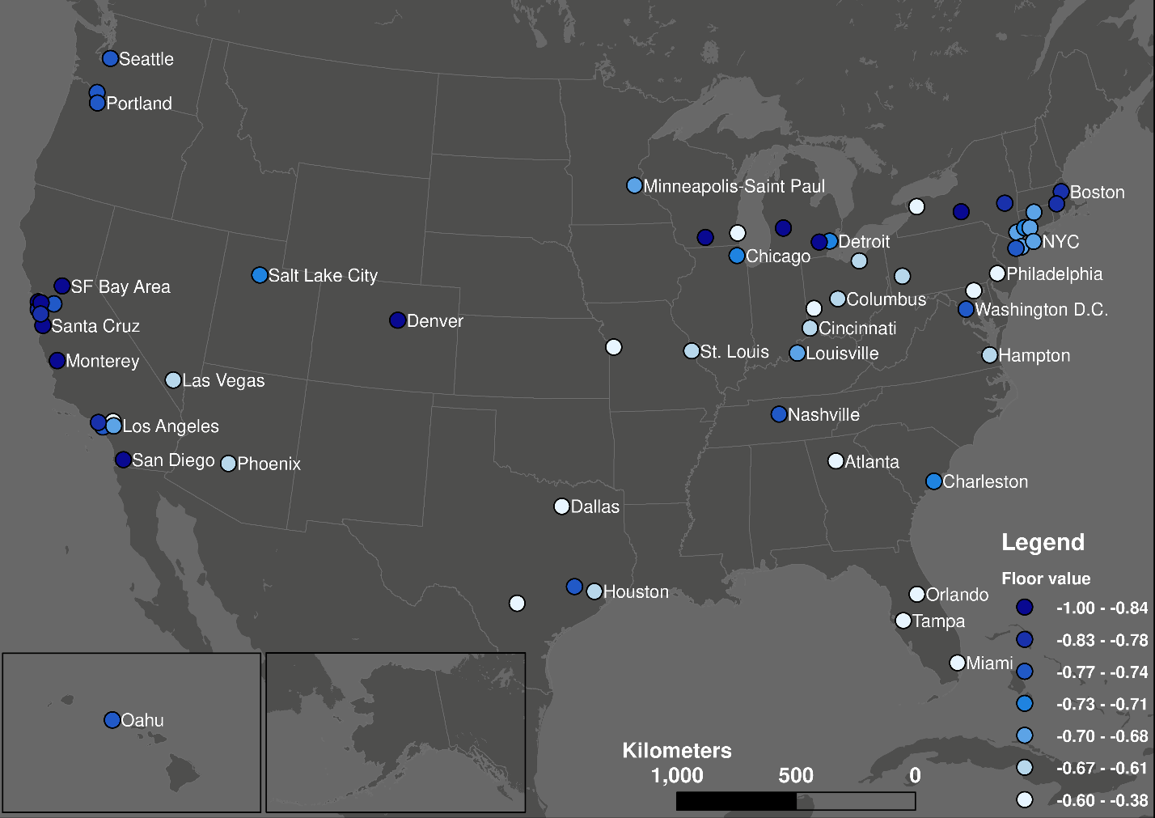

Fig 2. The distribution of floor values across the United States (quantile classification).

Table 1 provides results from the regression analysis related the floor values across transit systems with socio-economic and awareness indicators in each community. Four indicators are significant (α = 0.05). We did not include Hispanic population ratio or median income in the final model because of multicollinearity with the ratio of people with non-physical occupations. An F test shows the model is significant (p < 0.001). The R-squared value is 0.38. A residuals assessment shows that the residuals are normally distributed and there are no lingering multicollinearity effects.

|  |  |  |  |  |  |  |
| --- | --- | --- | --- | --- | --- | --- |
|  | Estimate coefficient | Standard Error | t value | Pr(>|t|) | Variance Inflation Factor | R-squared increment |
| Intercept | -0.52997 | 0.169042 | -3.135 | 0.00221 | - | - |
| Ratio of people with non-physical occupation | -0.4269 | 0.129248 | -3.303 | 0.0013 | 1.21 | 0.063 |
| Ratio of African American population | 0.412221 | 0.075941 | 5.428 | 3.53E-07 | 1.08 | 0.17 |
| Ratio of population over 45 years old | 0.856343 | 0.264103 | 3.242 | 0.00158 | 1.05 | 0.061 |
| Google search trend index | -0.00502 | 0.00197 | -2.55 | 0.01217 | 1.21 | 0.037 |

Table 1: Results from regression analysis of floor values with socio-economic and awareness indicators

* + 1. Population with non-physical occupations

The results confirm the hypothesis that greater decreases in transit demand are associated with a higher percentage of people with non-physical occupations. People who can work at home avoid public transit; people who cannot work at home and rely on public transit continue to use it.

Although we did not include the Hispanic population indicator due to multicollinearity, a very significant negative correlation between Hispanic population and population with non-physical occupations suggests vulnerability of Hispanic populations during this health crisis: if a city has a higher Hispanic population, it is likely for the city to have a higher floor value, which means more people use transit during the pandemic (presumably for work). This is also consistent with the occupation statistics: according to the labor force characteristics survey made by the US Bureau of Labor Statistics, the Hispanic population has the lowest percent (22%) of management, professional, and related occupations compared with White (41%), African American (31%), and Asian people (54%) in 2018 [36].

These results are also supported by user surveys conducted by Transit app in April 2020. According to the survey results, 92% of all the surveyed users reported that they still use public transit to commute to work [27]. Meanwhile, the top-four occupation categories that are most likely to still using transit are production, installation, maintenance and repair, food preparation and serving related, and protective service. Although the categorizations of the survey and the ACS data are different, this is generally consistent with the non-physical occupation categories we derived from that data.

The Transit survey also indicates that Spanish speakers are more likely to continue using the Transit app for trip planning purposes: English-language users dropped 71% from early February while Spanish-language users dropped by 50% over the same time period [28]. The income correlation is also confirmed by the survey results: compared with the survey results conducted by American Public Transportation Association (APTA) in 2017, active users skew towards lower income brackets during the pandemic, especially for those whose annual income is less than $15000 [28]. The survey results provide first-hand evidence and reaffirm the correlation results about the vulnerability of Hispanic population and low-income population.

* + 1. Age

The ratio of the population over 45 years old is associated with higher floor values; older people in a community mean higher levels of continued transit use during the pandemic. This result is also supported by the Transit user survey. By comparing the users’ age composition in surveys conducted in September 2019 and April 2020, Transit found a drop in young people under 18 and between 25 to 44 years old; meanwhile, the relative ratio of people between 45 to 64 years old doubled [28].

* + 1. African American

The regression analyses also suggest the dependence of African Americans on public transit, even during a pandemic. It is the most influential among the factors in Table 1 based on model fit (R-squared). There is a strong positive correlation between the ratio of African Americans in the population and the floor value. These results are also consistent with the results of the user survey. During the pandemic, African American people have the greatest share (>35%) of riders compared with other races in the US, while Caucasian were the majority (>40%) of the rider before the pandemic based on the 2017 APTA survey [27]. The disproportionately small decrease of the African American population’s transit demand supports the conclusion that cities with more African Americans are more likely to have a higher floor value.

Higher floor values are also highly correlated with larger ratios of females in the population; however, we also do not include it due to multicollinearity with the ratio of African Americans in the population. A higher ratio of females in the population is also correlated with lower income and a lower ratio of people with non-physical occupations. The Transit user survey supports these results in a dramatic manner. Among all the US users surveyed, the male and female proportions were roughly equal before the COVID-19 pandemic; during the pandemic, 56% are females while only 40% are males [27]. For some cities such as Philadelphia, more than 68% of riders are women. Meanwhile, Transit app users of color are also more likely to be females during the pandemic; more than 70% of the African-American riders during the pandemic are female [27].

* + 1. Awareness

The Google search trend index for COVID-19 is significantly associated with the floor value; cities with a higher search index tend to have a lower floor value, as a higher search index means COVID-19 has a higher ratio among all Google searches in that region. This indicates the effects of people’s awareness and concern: with more people perhaps following the stay-at-home order, more will avoid unessential public transit trips. However, in Table 1, Google search trend index is not highly influential: it has the lowest R-squared increase. It shows that people’s race, job, and age composition outweigh the awareness or preference when it comes to whether people will stay at home.

* + 1. Transit dependency

The Transit user survey found 85% of users do not have access to a car, supporting that transit passengers during the pandemic are mostly captive passengers. Surprisingly, the ACS data on people using transit to commute and households with no vehicles do not have a significant correlation with floor values. This suggests that the ACS dataset may not be a good metric for transit dependency during an emergency such as a pandemic. For example, the presence of a vehicle in a household does not mean it is reliable, affordable to operate, or available to a given household member. Also, transit dependency is heterogeneous in many US cities: while most residents are not transit dependent, there are neighborhoods with concentrated poverty and transit dependence [37,38]. The user survey shows that access to private vehicles is highly heterogeneous for different household income levels [27].

* 1. **Response intervals**

Fig 3 shows the distribution of the response interval measures in the US relative to the cliff and floor time points with no incubation lag. For cliff point response intervals, the pattern is highly polarized. In some cities with international airports, such as Seattle where the first US COVID-19 cases were found, people still used transit after the first case emerged. Meanwhile in other cities, such as most cities in the Midwest with the exception of Chicago, people started avoiding transit trips in advance of confirmed local community spread. This may be due to Seattle's precedence in COVID-19 spread in America: the media began to report the severity of this disease and the CDC made the prediction that the community spread is inevitable near the end of February 2020 [39].

The response interval patterns in Fig 3 suggest that initial declines in public transit usage may have limited the spread of the disease in some communities; 61% of all transit systems have a positive response interval. However, the picture is less sanguine after we factor in incubation lag and the ratio of positive response interval decreases to 33%. New York City is an illustrative example. With lag = zero days, five of 13 systems have positive response intervals, suggesting declines in transit usage in advance of community spread. With lag = five days, all 13 transit systems have negative response intervals, meaning the virus could have been spreading in the community before any appreciable decline in transit demand. In contrast, most transit systems in the Midwest such as Missouri, Ohio, Michigan, and Kentucky still have positive response intervals with an incubation lag of five days. This is supported by cellphone location data: those Midwest states above had known stay-at-home orders before March 27th and the measured trips are significantly less [40]. For a more conservative scenario of an incubation lag = 14 days, most transit systems (93.5%) have negative response intervals.

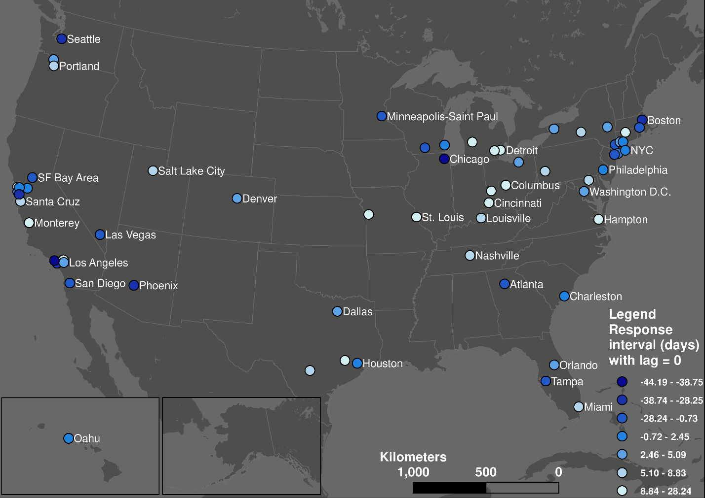

Fig 3. The geographic pattern of response interval with incubation lag =0 from cliff point (quantile classification).

However, the geographic pattern is highly homogeneous for the response intervals from floor point, which represent how early each transit system’s users finished the stay-at-home process compared to the community spread. For the scenario of lag = 0, only Capital Metro in Austin, Texas has a positive response interval. For the case of Austin, the demand decrease started on March 5th and finished by March 23nd; the first case was confirmed on March 25th. However, long before the first confirmed case, the city and county authority declared a local state of emergency on March 6th [41], which is one of the earliest places to take actions in the United States. The cliff point is also the same as the date of the local state of emergency, which suggests the effectiveness of the executive order. This can be one reason for the relatively fast and earlier reaction of transit users. The correlation analysis between the cliff point and the date of declaring state emergency moreover support this claim: it shows that an earlier cliff point is positively correlated (p = 0.002) with an earlier emergency date. It shows people’s response time is not synchronized with the evolution of the pandemic, but with the local government’s policy.

* 1. **Decay rate**

Fig 5 shows the geographic pattern of decay rate. Transit systems in the north, especially those in larger communities, and college towns reached their floor values the quickest while transit systems in the Midwest and southern communities took the longest to reach their floors. College towns emptied quickly during the pandemic. The slower decay rate in the Midwest and South may be explained by businesses staying open longer during the pandemic.

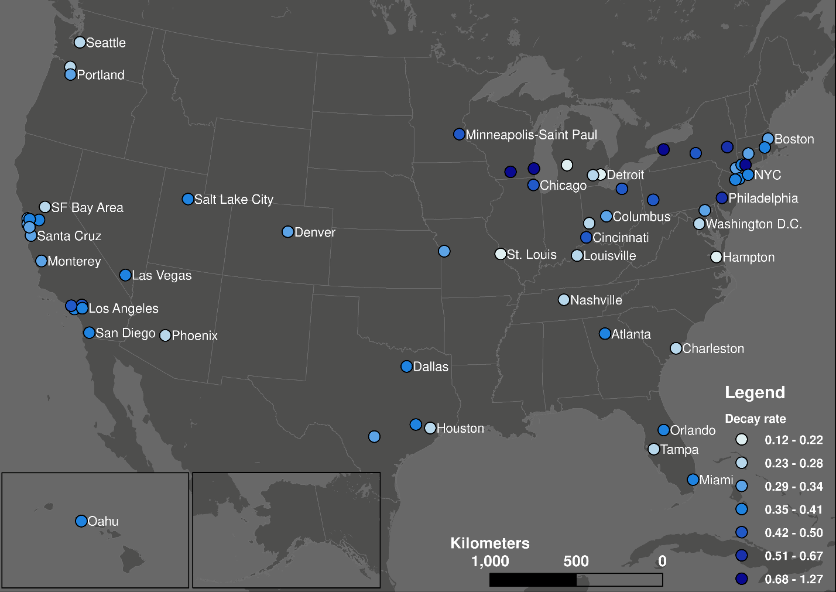

Fig 4. Geographic distribution of decay rate (quantile classification).

Fig 5 shows the decay rate has a positive hyperbolic correlation with cliff point and a negative hyperbolic correlation with floor point, as formulas (5) and (6) suggested. This indicates that the later the demand decline happened, the faster it occurred, and the decline process finished earlier. This could be because the general transit passengers may be more aware of the risk of COVID-19 when more cases are reported nationally; the perceived fear grows higher as the time passed, causing transit users to act faster and reach the floor point earlier. This also suggests that the time when the decline finished is less related to when it started than to the speed of reaction. The major determinant of the cliff and floor point in formula (5) is decay rate instead of *t0*.

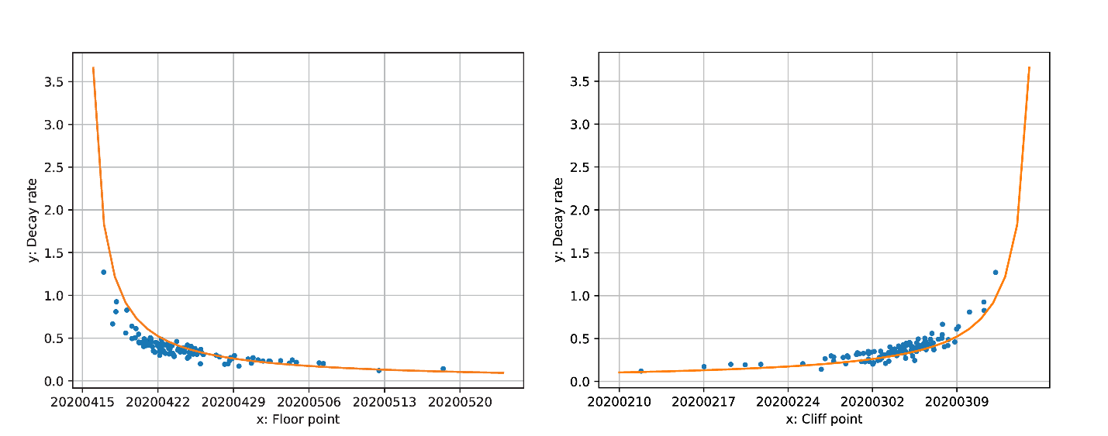

Fig 5. Hyperbolic relationship between decay rates and cliff points.

**3.4.** **Change in daily transit demand dynamics**

Overall, we observe a connection between a change in hourly demand patterns (measured by the Procrustes distance) and the total drop in demand due to COVID-19 (measured by the floor value). Fig 6 shows the geographic distribution of each transit system’s average Procrustes distance between its normal and pandemic hourly demand curves. This map shows a similar pattern to the geographic distribution of floor values (Fig 2): transit systems serving communities that are dominated by non-physical occupations (including university towns) experienced large qualitative changes in their weekday hourly demand patterns. In contrast, the Procrustes distances between normal and pandemic hourly transit demand profiles of communities in the Midwest and Northeast is low, meaning these transit systems retained much of their typical daily demand profile (albeit with lower levels of overall demand). Fig 7 confirms the strong correlation between the Procrustes distance and floor values: higher levels of base demand during the pandemic also means less shift from the typical hourly demand profile.

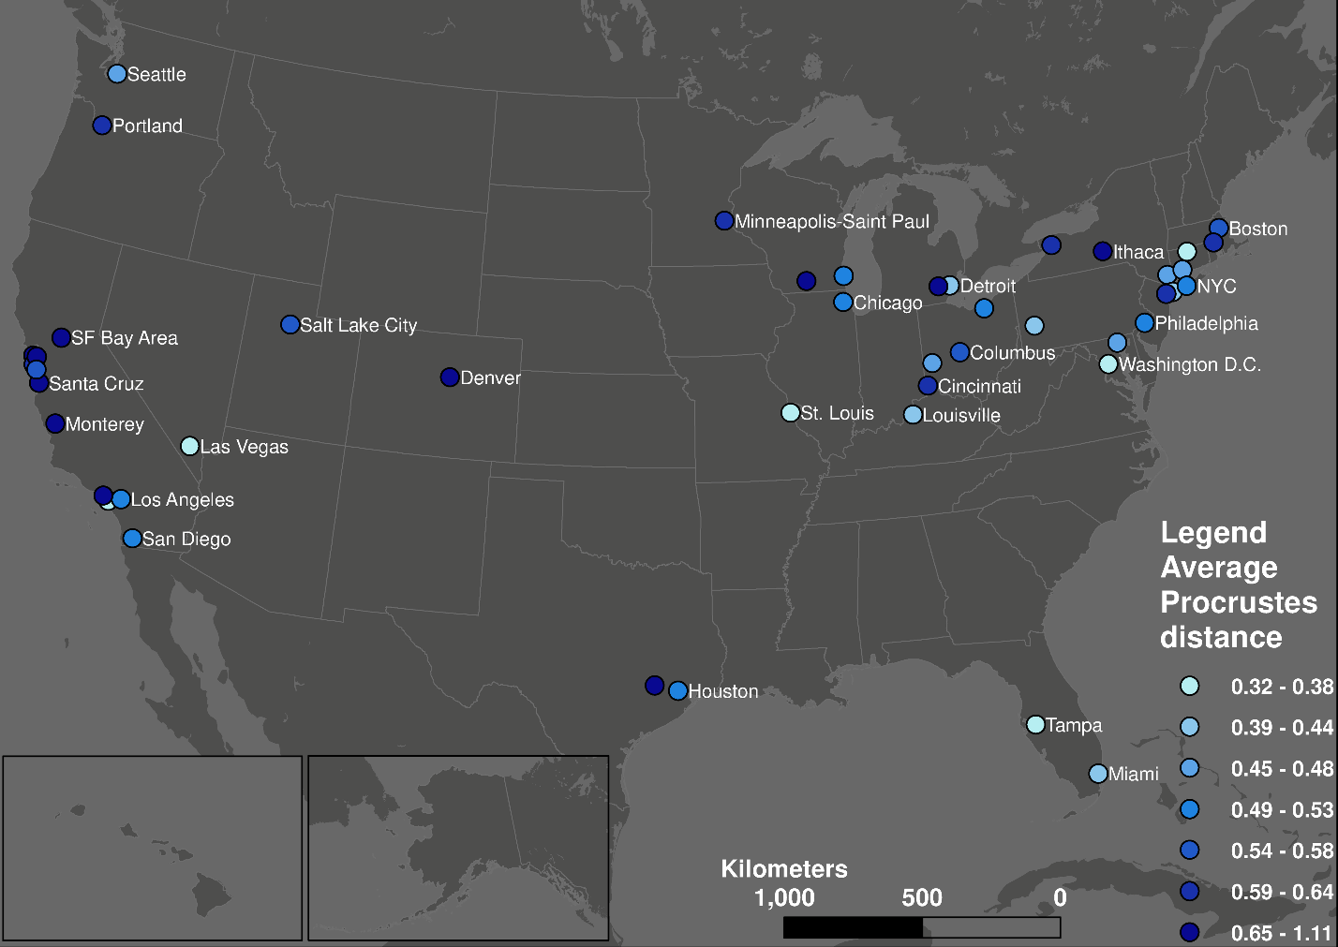

Fig 6. Geographic distribution average Procrustes distance between normal and pandemic weekday hourly demand curves.

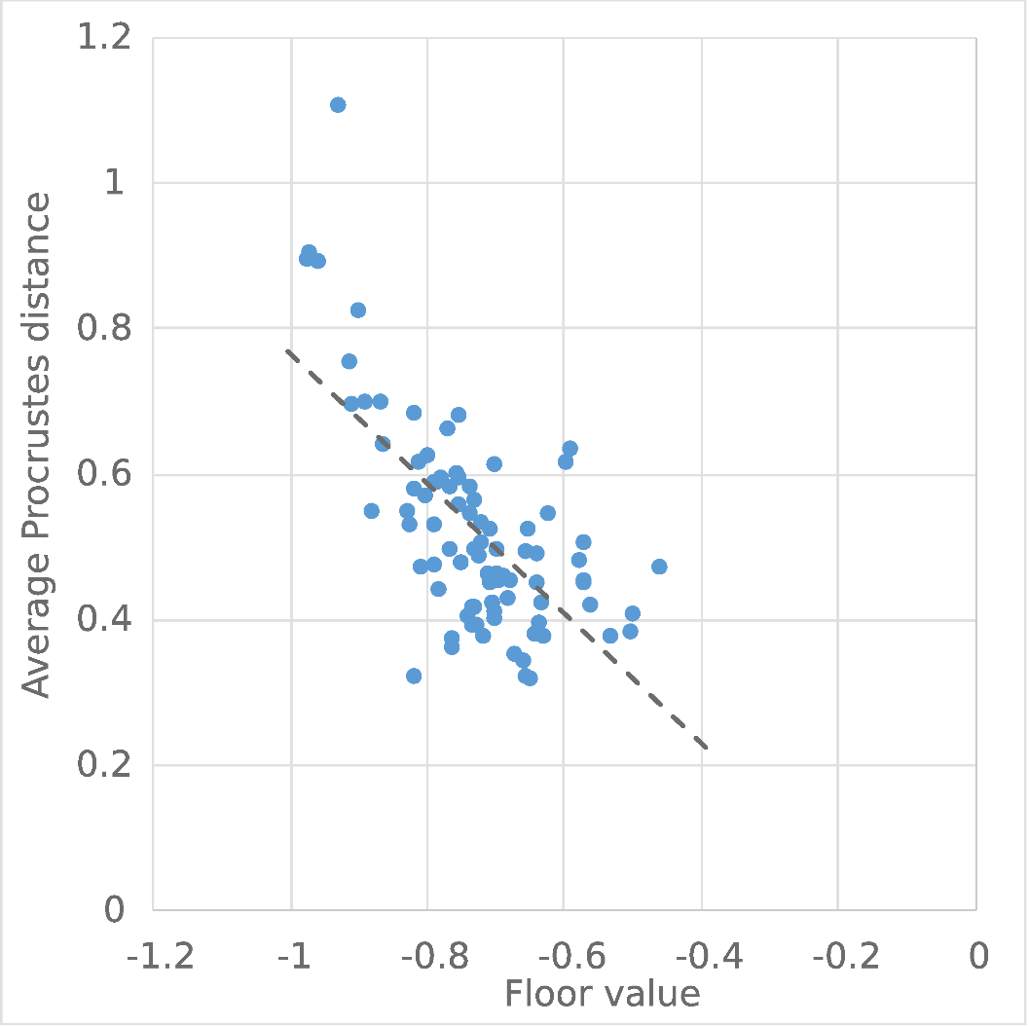

Fig 7. Relationship between average Procrustes distance and floor value.

Fig 8 shows the daily distribution of all the transit systems’ average Procrustes distance between its normal and pandemic hourly demand curves. We see a pattern of a period of increasing difference during first few weeks, re-stabilization at a higher level, and a signal of decline at the very end. This means that the hourly demand dynamics gradually diverge from the normality, stabilize, and then show signs of returning to normal.

The Procrustes distance value also shows a regular periodical pattern: the distances are higher for weekdays (black points in Fig 8) than weekends (blue points in Fig 8), which means the hourly demand pattern diverged from normal more on weekdays than weekends. By visualizing the hourly demand pattern, we note that weekday and weekend hourly demand patterns became more similar. To confirm this, we calculate the Procrustes distances between weekdays and weekends. These distances decreased for all transit systems during the pandemic. Two factors could be powering this convergence between weekday and weekend hourly demand patterns. First is the disproportional sudden decrease of the morning and afternoon commuting activities in the weekdays. This change will generally flatten the peaks and diminish the contrast between normal hours and rush hours. This process is essentially driven by the privileged population with non-physical occupations: their absence made weekdays more like weekends. Second, the reduction of unessential activities, such as leisure and shopping trips, also make commuting-relevant trips more prominent during the weekends. This effect is especially obvious in the New York City for its population highly relies on public transit and the non-physical occupation’s rate is not high. For example, for the Metropolitan Transportation Authority (MTA) systems, the curves of Sundays usually have one peak during 2 – 4 pm; however, the shape of the Sunday curves during the pandemic had two peaks, which was similar to the weekdays’ commuting pattern. This process is meanwhile driven by the underprivileged population that still have to work during the weekends: their stay made weekends more like weekdays. These two factors homogenized each day of week and make the boundary between weekends and weekdays less obvious.

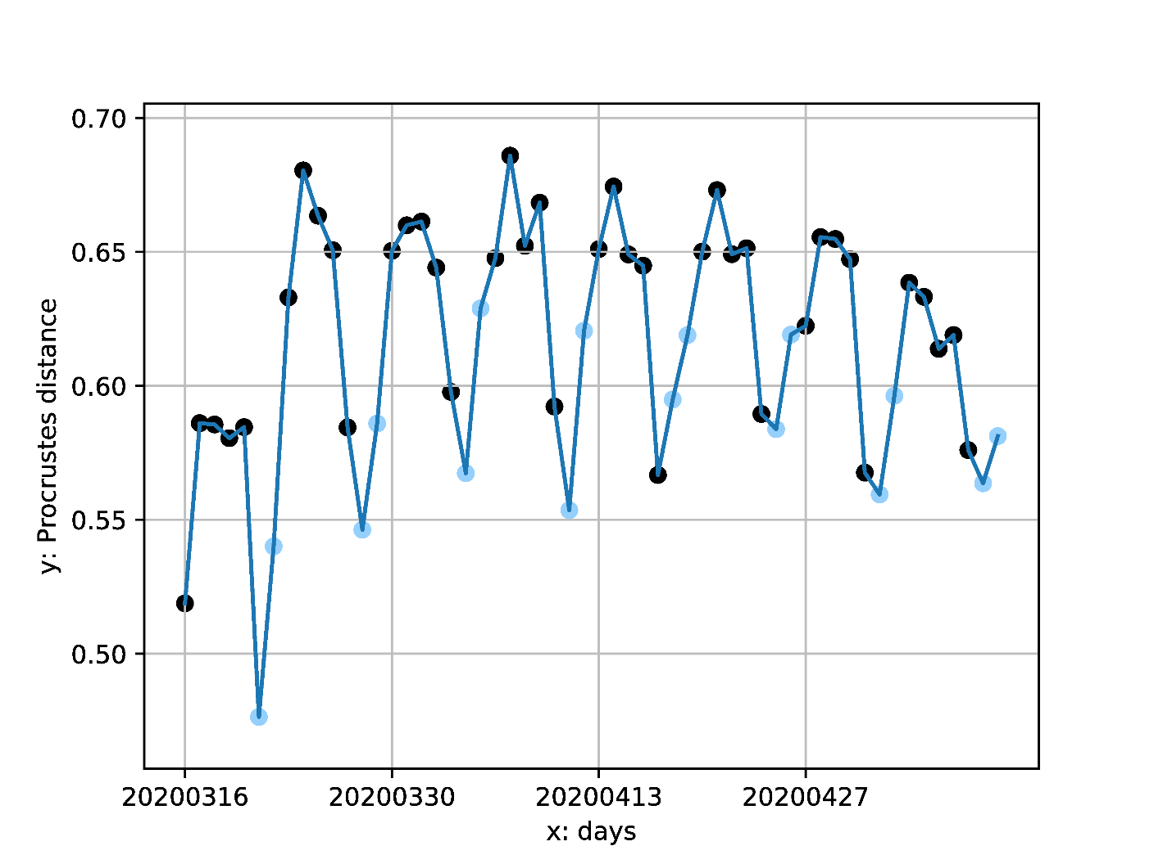

Fig 8. Temporal distribution of all transit system's average Procrustes distance between normal and pandemic curves.

Black points: weekdays; blue points: weekends.

1. **Conclusion**

In this paper, we use activity data from a widely used public transit navigation app to measure changes in demand for 113 transit systems across the United States during the COVID-19 pandemic. We fit logistic curves describing declines in daily transit system demand and derive parameters describing the decline dynamics. We also compare differences in hourly demand profiles on weekdays and weekends.

The minimum value of the transit demand curve, *floor value*, is an indicator of transit as an essential service: it shows continued use transit system regardless of the pandemic; most likely people who are transit dependent and perform essential jobs and other activities. Geographic patterns shows information industry dominating areas and university cities have lower floor values. Further linear regression with floor value and different socioeconomic and demographic factors shows that: cities with less non-physical occupations ratio, larger ratio of minority population (African American, Female, Hispanic), more middle-age and senior people over 45 years old, and lower “Coronavirus” relevant search trend index tend to have higher floor value. The user demographic survey conducted by Transit app supports these conclusions. These results affirm a stark fact: **cities with more essential workers and a more vulnerable population tend to maintain higher transit demand levels during COVID-19**. This moreover suggests the necessity of the transit system even during a pandemic when transit systems lose a great deal of discretionary demand. This should motivate transit planners, policy makers, political leaders, and taxpayers to rethink the role of transit systems not as a business, but as a social welfare to protect and serve the essential and vulnerable people in their communities.

It is noteworthy that floor values are not associated with the ratio of transit commuters and households with no access to private vehicles from the US Census American Community Survey. This suggests that these commonly used measures are not adequate for describing essential transit demand during a crisis such as a pandemic. These variables may not capture transit dependence since transit commuters during normal times include both choice and dependent riders. Also, having at least one vehicle per household does not mean that individuals have ready access to reliable transportation. This suggests a need for developing more accurate measure of transit dependency for use in crises.

The start and end date of transit demand curve, *cliff point* and *floor point*, show when discretionary transit demand—people who can work at home or do not work, and people who have other mobility options—started and finished its decline due to COVID-19. We moreover compare cliff/floor point with the first day of local community spread and the results shows that people’s response time is not synchronized with the development of the disease; instead, the cliff point is correlated with the date of declaring state of emergency for each state. 54% of all transit systems experienced a decline in discretionary travel demand before local community spread started. However, this pattern is less sanguine when we factor in incubation lags: the number drops to 24% with the reported median incubation period of five days and moreover drops to 5% with the reported maximum incubation period of 14 days. Meanwhile, almost no transit systems’ discretionary demand clear fast enough to reach the floor point before community spread.

The speed of the decline, *decay rate*, shows how fast the decline process is. The correlation reveals that faster decay rate is associated with later cliff point and earlier floor point. This could be because of growing awareness and fear as time passed to make people to act faster. This also suggests that the end date of the decline (floor point) is mostly determined by the reaction speed (decay rate) but not the start date of the decline (cliff point).

The commuting analyses based on hourly transit demand data show that essential passengers’ commuting routine during the pandemic is substantially different from the normal routine. The pattern of Procrustes distances measuring differences between the normal and pandemic weekday demand profiles is geographically polarized and highly correlated with the floor value: systems with higher floor values (e.g., communities in the Northeast and Midwest) retain more of their hourly demand pattern than systems with lower floor values (e.g., communities with a large number of non-physical occupations, including cities in California, and university towns where a large proportion of the population left). The impact on hourly demand profiles increased as the pandemic developed. The pandemic also made the weekdays and weekends less different due to disproportional decrease of the morning and afternoon commuting activity, which made the difference between rush hours and normal hours less obvious; meanwhile weekdays are more like weekends because the cessation of unessential businesses made the weekends trips become commuting-dominating. Moreover, the pandemic shifted the morning and afternoon rush hours. Morning rush hour shift is very heterogeneous for different cities with average shift of -0.05 hours but the afternoon rush hour shifted homogeneously later for 1 hour in average.

The paper is a first approximation of understanding the heterogeneous impacts of a major pandemic such as COVID-19 on transit systems in the United States. Our study highlights public transit as an essential service during a pandemic and the vulnerabilities of some social groups (women, Hispanic, African-Americans) as they travel to perform essential activities. Additional research should build on this study to resolve some of its limitations and more deeply investigate the patterns discovered. One limitation of our study concerns the representativeness of the transit demand data for actual ridership.We use data from the Transit app as a surrogate for demand since actual passenger counts for systems at a national level are difficult to obtain. Although a test between official ridership data and the transit demand data for some systems suggest no significant differences overall, transit system-level comparisons should nevertheless be viewed as tentative. Data from automated passenger counting technologies, smart card or other transit pass data would allow more definitive comparison, albeit at a system level and not at the national level as in this paper.

Another limitation concerns the geographic resolution of the data is each transit system. We make our comparison using system level data and its corresponding county-equivalent. This can mask important differences within each system (e.g., route-by-route changes) and across neighborhoods within each community. Again, this calls for a deeper investigation within each system.

Finally, there is a need for attitudinal and behavioral surveys and analysis to confirm some of the patterns suggested in this study about ridership during a pandemic, individuals' perceptions and their reactions. With this more nuanced understanding of individual public transit behavior during a pandemic, we can help design effective public transit systems that meet the needs of vulnerable passengers using transit to perform essential activities, creating transportation systems that are more inclusive and resilient to shocks.

**References**

1. Weber H. Air traffic data shows less crowded skies since the coronavirus spread. 2020 [cited 2 Apr 2020]. Available: https://www.fastcompany.com/90485186/its-time-to-cancel-rent

2. Bliss L. When the World Stops Moving. 2020 [cited 20 May 2020]. Available: https://www.citylab.com/transportation/2020/03/coronavirus-impact-public-transit-street-traffic-data-trains/607915/

3. WMATA. Metro and Covid-19: Steps we’ve taken. 2020 [cited 2 Apr 2020]. Available: https://www.wmata.com/service/status/details/COVID-19.cfm

4. Christensen K. COVID-19 drives down ridership as El Dorado Transit adapts. 2020 [cited 4 Feb 2020]. Available: https://www.mtdemocrat.com/news/covid-19-drives-down-ridership-as-el-dorado-transit-adapts/

5. Tan S, Fowers A, And DK, Tierney L. Amid the pandemic, public transit is highlighting inequalities in cities. In: Washington Post [Internet]. 2020 [cited 16 May 2020]. Available: https://www.washingtonpost.com/nation/2020/05/15/amid-pandemic-public-transit-is-highlighting-inequalities-cities/?arc404=true

6. Zhao J, Webb V, Shah P. Customer loyalty differences between captive and choice transit riders. Transp Res Rec. 2014;2415: 80–88.

7. Zimmerman R. Mass transit infrastructure and urban health. J Urban Heal. 2005;82: 21–32.

8. Yellin J. North Americans Turning Away From Public Transit As Direct Result Of COVID-19. 2020 [cited 4 Feb 2020]. Available: https://www.northstarhub.com/posts/north-americans-turning-away-from-public-transit-as-direct-result-of-covid-19

9. Wang K-Y. How change of public transportation usage reveals fear of the SARS virus in a city. PLoS One. 2014;9.

10. Kim C, Cheon SH, Choi K, Joh C-H, Lee H-J. Exposure to fear: Changes in travel behavior during MERS outbreak in Seoul. KSCE J Civ Eng. 2017;21: 2888–2895.

11. Transit app. Transit • Bus & Subway Times. 2020 [cited 4 Feb 2020]. Available: https://play.google.com/store/apps/details?id=com.thetransitapp.droid&hl=en_US

12. App Store Preview - Transit • Subway & Bus Times. 2020 [cited 23 May 2020]. Available: https://apps.apple.com/app/apple-store/id498151501

13. Transit app. How coronavirus is disrupting public transit. 2020. Available: https://transitapp.com/coronavirus#monitor

14. Biocomplexity Institute U of V. COVID-19 Surveillance Dashboard. 2020. Available: https://nssac.bii.virginia.edu/covid-19/dashboard/

15. JHU CSSE. 2019 Novel Coronavirus COVID-19 (2019-nCoV) Data Repository by Johns Hopkins CSSE. 2020 [cited 15 May 2020]. Available: https://github.com/CSSEGISandData/COVID-19/

16. USAFacts. Coronavirus Locations: COVID-19 Map by County and State. 2020 [cited 15 May 2020]. Available: https://usafacts.org/visualizations/coronavirus-covid-19-spread-map/

17. U.S. Bureau of Labor Statistics. Table 1. Workers who could work at home, did work at home, and were paid for work at home, by selected characteristics, averages for the period 2017-2018. 2019 [cited 16 May 2020]. Available: https://www.bls.gov/news.release/flex2.t01.htm

18. Cooke TJ. Geographic access to job opportunities and labor-force participation among women and African Americans in the greater Boston metropolitan area. Urban Geogr. 1997;18: 213–227.

19. Golub A, Marcantonio RA, Sanchez TW. Race, space, and struggles for mobility: transportation impacts on African Americans in Oakland and the East Bay. Urban Geogr. 2013;34: 699–728.

20. Iseki H, Taylor BD. The demographics of public transit subsidies: a case study of Los Angeles. 2010.

21. Centers for Disease Control and Prevention. Coronavirus 2019 (COVID-19) Surveillance. 2020 [cited 21 Apr 2020]. Available: https://www.cdc.gov/nchs/nvss/vsrr/covid19/index.htm

22. Lin Y-H, Liu C-H, Chiu Y-C. Google searches for the keywords of “wash hands” predict the speed of national spread of COVID-19 outbreak among 21 countries. Brain Behav Immun. 2020.

23. Li C, Chen LJ, Chen X, Zhang M, Pang CP, Chen H. Retrospective analysis of the possibility of predicting the COVID-19 outbreak from Internet searches and social media data, China, 2020. Eurosurveillance. 2020;25: 2000199.

24. Yuan GX, Di L, Gu Y, Qian G, Qian X. The Prediction for the Outbreak of COVID-19 for 15 States in USA by Using Turning Phase Concepts as of April 10, 2020. Available SSRN 3575002. 2020.

25. Google. Google Trends - COVID19. 2020 [cited 5 Dec 2020]. Available: https://trends.google.com/trends/explore?date=today 3-m&geo=US&q=COVID19

26. Google. Google Trend Compare (COVID19, Coronavirus). 2020 [cited 21 May 2020]. Available: https://trends.google.com/trends/explore?geo=US&q=COVID19,Coronavirus

27. Transit app. Who’s left riding public transit? Hint: it’s not white people. 2020 [cited 15 May 2020]. Available: https://medium.com/transit-app/whos-left-riding-public-transit-hint-it-s-not-white-people-d43695b3974a

28. Transit app. Who’s Onboard? Surveying Transit Riders During the Coronavirus Pandemic. 2020 [cited 15 May 2020]. Available: https://www.youtube.com/watch?v=qkT9XQtd1o4

29. Lauer SA, Grantz KH, Bi Q, Jones FK, Zheng Q, Meredith HR, et al. The incubation period of coronavirus disease 2019 (COVID-19) from publicly reported confirmed cases: estimation and application. Ann Intern Med. 2020.

30. Cheng H-Y, Jian S-W, Liu D-P, Ng T-C, Huang W-T, Lin H-H. High transmissibility of COVID-19 near symptom onset. medRxiv. 2020.

31. Pan X, Chen D, Xia Y, Wu X, Li T, Ou X, et al. Asymptomatic cases in a family cluster with SARS-CoV-2 infection. Lancet Infect Dis. 2020;20: 410–411.

32. Dong Y, Mo X, Hu Y, Qi X, Jiang F, Jiang Z, et al. Epidemiological characteristics of 2143 pediatric patients with 2019 coronavirus disease in China. Pediatrics. 2020.

33. Achenbach J, Mettler K, Sun LH, Guarino B. Coronavirus may have spread undetected for weeks in Washington state, which reported first two deaths in U.S. In: Washington Post [Internet]. 2020 [cited 4 Mar 2020]. Available: https://www.washingtonpost.com/health/coronavirus-may-have-spread-undetected-for-weeks-in-washington-state/2020/03/01/0f292336-5bcc-11ea-9055-5fa12981bbbf_story.html

34. Popovich N. How U.S. Coronavirus Diagnoses Are Lagging Behind the Outbreak. 2020 [cited 4 Mar 2020]. Available: https://www.nytimes.com/interactive/2020/04/01/us/coronavirus-covid-19-symptoms-data.html

35. Mitteroecker P, Gunz P, Windhager S, Schaefer K. A brief review of shape, form, and allometry in geometric morphometrics, with applications to human facial morphology. Hystrix, Ital J Mammal. 2013;24: 59–66.

36. U.S. Bureau of Labor Statistics. Labor force characteristics by race and ethnicity, 2018. 2018 [cited 27 Apr 2020]. Available: https://www.bls.gov/opub/reports/race-and-ethnicity/2018/home.htm

37. Pathak R, Wyczalkowski CK, Huang X. Public transit access and the changing spatial distribution of poverty. Reg Sci Urban Econ. 2017;66: 198–212.

38. Giuliano G. Low income, public transit, and mobility. Transp Res Rec. 2005;1927: 63–70.

39. McLauphlin EC. CDC official warns Americans it’s not a question of if coronavirus will spread, but when. 2020 [cited 4 Feb 2020]. Available: https://www.cnn.com/2020/02/25/health/coronavirus-us-american-cases/index.html

40. Glanz J, Carey B, Holder J, Watkins D, Valentino-DeVries J, Rojas R, et al. Where America Didn’t Stay Home Even as the Virus Spread. In: The New York Times [Internet]. 2020 [cited 4 Apr 2020]. Available: https://www.nytimes.com/interactive/2020/04/02/us/coronavirus-social-distancing.html?referringSource=articleShare

41. Evans E. City, county leaders declare local state of disaster due to coronavirus concerns. 2020 [cited 4 Apr 2020]. Available: https://www.fox7austin.com/news/city-county-leaders-declare-local-state-of-disaster-due-to-coronavirus-concerns